Visio-conférence N °4 : Fiche élève

Christmas in my family

1. We usually have a white Christmas. There is a lot of snow! | 2. People decorate their houses to celebrate Christmas. They put lights and decorations outside. | 3. On Christmas Eve, the 24th of December, I go to church with my mom, my dad, and my sister. | 4. After church, we go home to eat a small, but nice dinner.
5. After the meal, we open presents from each other. | 6. On Christmas morning, the 25th of December, we open our presents from Santa. He leaves the presents in stockings that we hang over the fireplace. | 7. Then we go visit family. We see grandparents, aunts, uncles, and cousins. We give each other presents and eat a meal together.
Manque photo famille de Michelle (papa, maman et 2 soeurs ouvrant les cadeaux)

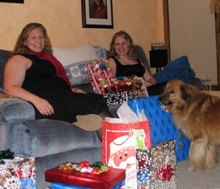 | 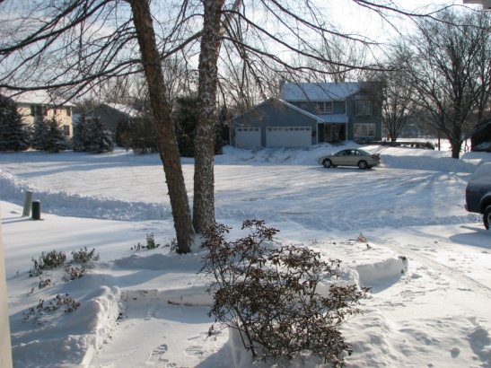 | 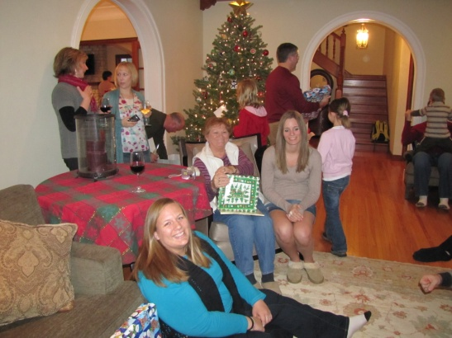 | 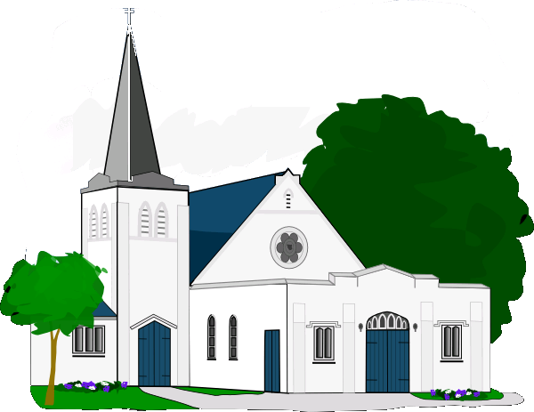
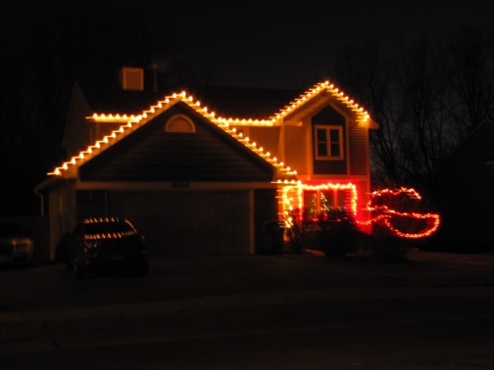 | 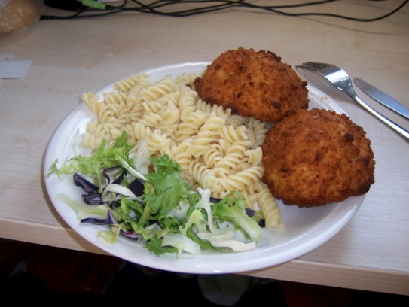 | 