Visioconférence avec une assistante: Module 2 / Séquence 5 : Se décrire – Lire

Read the text and colour in the faces.

[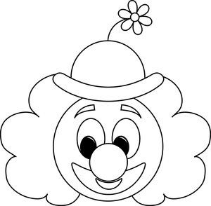](http://www.google.co.uk/url?sa=i&rct=j&q=&esrc=s&source=images&cd=&cad=rja&docid=4SHgv9cAAgfVmM&tbnid=114HdNTAcot3YM:&ved=0CAUQjRw&url=http://www.cartoon-clipart.com/cartoon_clipart_images/cartoon_clown_outline__good_for_a_coloring_page_0515-1004-1704-0247.html&ei=UzPhUqOXKeuX0AX8noG4CQ&bvm=bv.59568121,d.d2k&psig=AFQjCNHOmTTI_W0LDZDT8O_Ozsu6IAV4ew&ust=1390576843957105)

I have green hair.

I have a big pink nose.

I have a big yellow mouth.

I have big blue eyes.

My hat is orange.

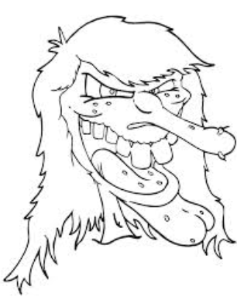

I have long grey hair.

I have a big green nose.

I have a big red mouth.

I have small purple eyes.

I have big yellow teeth.

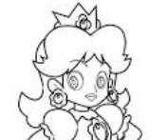

I have blonde hair.

I have a small pink nose.

I have a small red mouth.

I have blue eyes.

My crown is yellow.